Lion’s Mane Mushroom Kit Growing Instructions
FIRST: Find a suitable location:
Lion’s Mane mushrooms enjoy a growing temperature between 17 and 24 C. Select a location that receives some light, but never place the block in direct sunlight (this could overheat the mycelium). Avoid areas that experience temperature fluctuations throughout the day.
SECOND: Prep your block
- Position the block so that the side with the filter patch (white patch with writing) is facing up. Using a pointy pair of scissors or a sharp knife, cut two x-shaped, evenly spaced holes in the side facing up, directly on the sawdust/mycelium part of the block). Each x-shaped hole should be approximately 2-4 cm. This will be where your mushrooms will begin forming. DO keep the block encased in its bag; the only oxygen your block should receive is through the holes you cut.
- Stand the block up and deflate the top portion of the bag, folding it tightly over the side opposite where you cut the holes. Air from the bag will exhaust through the holes you cut in the block. You can tape the folded side down. Place the block on a cookie sheet or large plate with the holes you cut facing upwards. Mist the top of the block with water.
- Prepare your humidity tent: Cut eight to ten 5cm slits in the humidity tent (large clear plastic bag), and place over the block. Be sure the humidity tent allows light to pass through. The holes you cut in the humidity tent will allow for air movement while also helping to maintain high humidity for the block.
THIRD: Manage your block
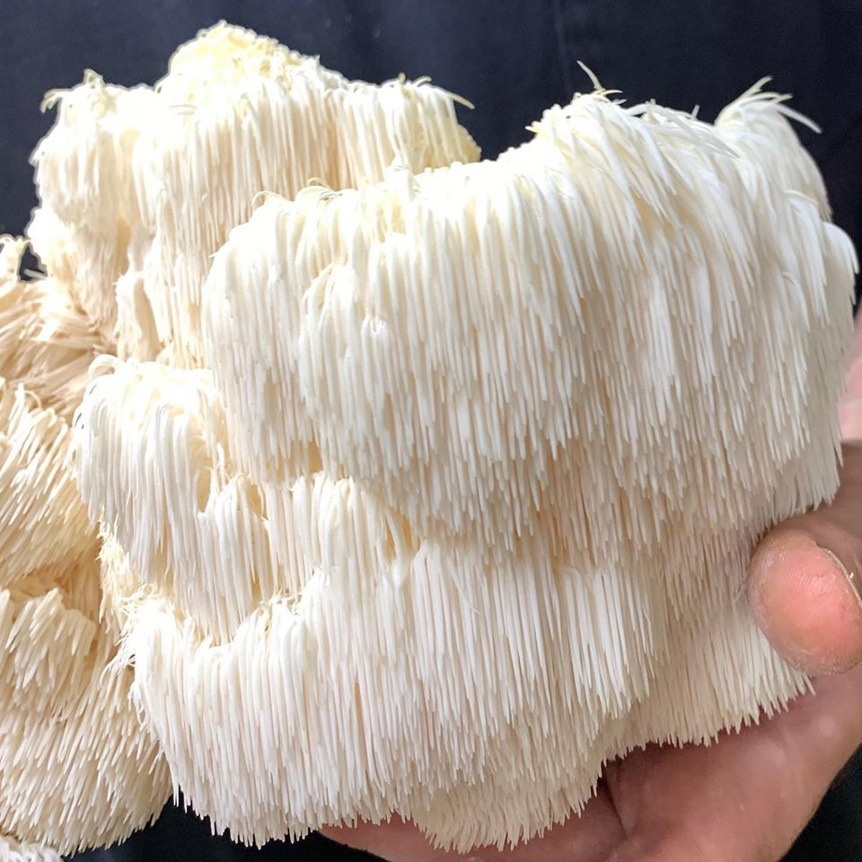
Mist the inside of the humidity tent with water 2 to 3 times per day. Usually within 7 -10 days you will begin to see fruit formation. Lion’s mane will look slightly pink and like a tight cluster of cauliflower at first. They will grow quickly, turning more cream/white, and developing their signature tendrils. Usually within 14 days you will harvest your first crop of mushrooms.
Harvest mushrooms when fruits begin to grow tendrils. Simply break them off the block, at the base of the mushroom, leaving no residue at the site where they are broken. (If you leave bits of mushroom behind, it will not continue to grow, but will become mouldy.) After all mushrooms have been harvested, the block will produce a second flush of mushrooms in about 14 days, at the same site of the first flush. Many people keep blocks for 1-3 or more flushes. A block that is well-cared-for can produce over 1.5lbs of mushroom. When your block is done, the spent mushroom substrate makes incredible compost! The plastic bag can be recycled.

